**COLLATZ CONJECTURE**

**INTRODUCTION:**

Collatz can be defined as a function whose value ends to 1. For any even number it is divided by 2(n/2) and for any odd number it is (3n+1).

The Collatz conjecture is a [conjecture](https://en.wikipedia.org/wiki/Conjecture) in [mathematics](https://en.wikipedia.org/wiki/Mathematics) that concerns a [sequence](https://en.wikipedia.org/wiki/Sequence) defined as follows: start with any [positive integer](https://en.wikipedia.org/wiki/Positive_integer) *n*. Then each term is obtained from the previous term as follows: if the previous term is [even](https://en.wikipedia.org/wiki/Parity_(mathematics)), the next term is one half of the previous term. If the previous term is odd, the next term is 3 times the previous term plus 1. The conjecture is that no matter what value of *n*, the sequence will always reach 1.

ai =n for i=0

= f(ai-1) for i>0

The collatz conjecture asserts that every n has a well-defined total stopping time. If, for some n if it does not terminate to 1 ,we say that n has infinite total stopping time and the conjecture is false.Such n will enter in a repeating cycle without any bound.**No such sequence has been found. We support this point because the program executed completely without entering an infinite loop in range 0 to 99999.**

The Collatz conjecture seems to say that there is some sort of abstract quantity like 'energy' which cannot be arbitrarily increased by adding 1. That is no matter where you start the end result is always 1.

**VISUALIZATIONS**

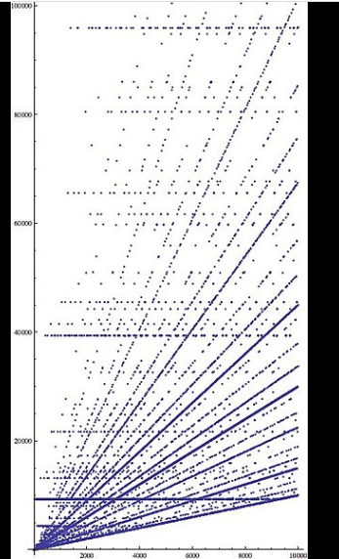

The x axis represents the starting number, the y axis represents the highest number reached during the chain to 1. This plot shows a restricted y axis: some x values produce intermediates as high as 2.7×107 (for x = 9663).

**DISADVANTAGES OF COLLATZ**

1.Computation Time: the user doesn’t know when the sequence will end.

2. Memory problems

**EXTENSIONS TO LARGER DOMAINS:**  
1. Iterating on integers including the negative integers(exceptions:0,1,-1,-5,-17)

2.Iterating on rational numbers

3.Iterating on complex numbers.

**METHODOLOGY**

1. In the code we have written a function collatz() in which the next number is calculated by performing operation on the current number. If the current number is even, we divide it by 2 and if it is odd, we use number=3n+1
2. Here we have considered a range of numbers from 1-1000. The iterations of every number till it reaches 1 is calculated
3. Histogram plot and the plot of iterations against the number was plotted. The results obtained are as follows-

**Plots obtained:**

**Range 1 to 999**

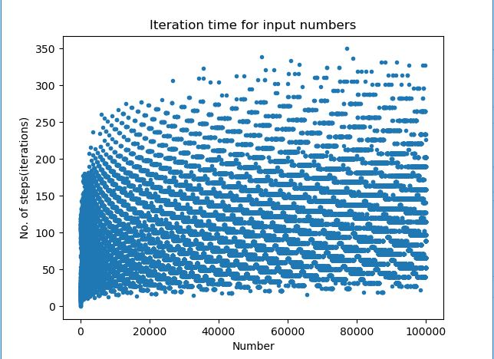

Histogram:

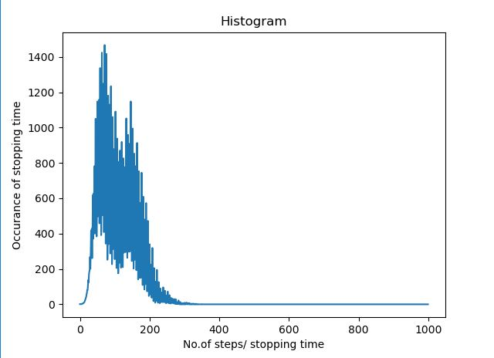

**If we visualize the number map it is like a tree. It has many leaf nodes but a single root.**